SQL Concepts & Fundamentals (16/07/2020)

Relational Database: MySQL

1. Create a database for the Hospital Management System based on your ER. Create appropriate tables & relationships.

DDL COMMANDS:

CREATE DATABASE HOSPITAL;

USE HOSPITAL

Default schema set to `HOSPITAL`.

CREATE TABLE patient( P_ID INT PRIMARY KEY, P_NAME VARCHAR(50), P_Address VARCHAR(200), contact CHAR(10));

CREATE TABLE department( dept_id INT PRIMARY KEY, dept_name VARCHAR(30));

CREATE TABLE doctor( doc_id INT PRIMARY KEY, doc_name VARCHAR(30), dept_id INT, FOREIGN KEY (dept_id) REFERENCES department(dept_id));

ALTER TABLE patient add admit_date DATE;

ALTER TABLE patient add discharge_date DATE;

ALTER TABLE patient add doc_id INT;

ALTER TABLE patient ADD FOREIGN KEY(doc_id) REFERENCES doctor(doc_id);

Inserting values:

TABLE DEPARTMENT:

INSERT INTO department VALUES(101, "cardiologist");

INSERT INTO department VALUES(102, "neurology");

INSERT INTO department VALUES(103, "gynaecology");

INSERT INTO department VALUES(104, "obstetric");

TABLE DOCTOR:

INSERT INTO doctor VALUES(201, "ramesh",101);

INSERT INTO doctor VALUES(202, "Kavita",101);

INSERT INTO doctor VALUES(203, "Rohan",101);

INSERT INTO doctor VALUES(204, "Kamal",102);

INSERT INTO doctor VALUES(205, "Sandra",103);

INSERT INTO doctor VALUES(206, "Jay",103);

INSERT INTO doctor VALUES(207, "Hrehal",104);

TABLE PATIENT:

INSERT INTO patient VALUES(1,"Amit", "delhi", "1234567890",'2020-07-10','2020-07-16',201);

INSERT INTO patient VALUES(2,"Paul", "delhi", "1234567890",'2020-07-10','2020-07-16',201);

INSERT INTO patient VALUES(3,"Ram", "delhi", "1234567890",'2020-07-02','2020-07-09',202);

INSERT INTO patient VALUES(4,"Franziska", "delhi", "1234567890",'2020-07-09','2020-07-14',204);

INSERT INTO patient VALUES(5,"Sheja", "delhi", "1234567890",'2020-07-01','2020-07-02',204);

INSERT INTO patient VALUES(6,"Gauri", "delhi", "1234567890",'2020-07-01','2020-07-17',205);

INSERT INTO patient VALUES(7,"Garisha", "delhi", "1234567890",'2020-07-01','2020-07-17',205);

INSERT INTO patient VALUES(8,"kedian", "delhi", "1234567890",'2020-07-01','2020-07-02',204);

INSERT INTO patient VALUES(9,"kunal", "delhi", "1234567890",'2020-07-01','2020-07-02',204);

INSERT INTO patient VALUES(10,"Komal", "delhi", "1234567890",'2020-07-09','2020-07-14',204);

Table Creation:

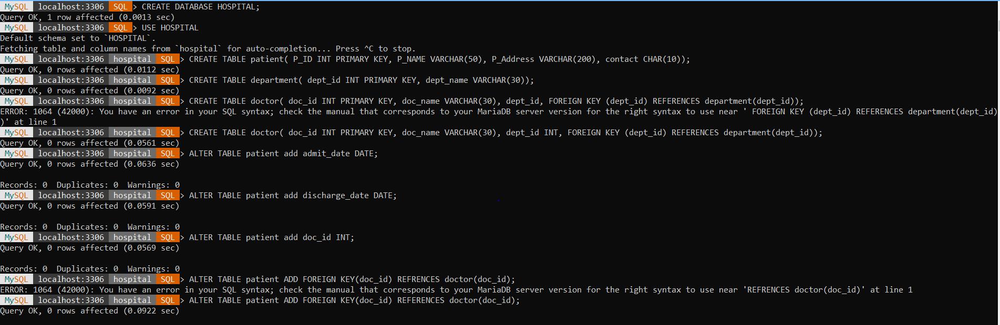

Tables after inserting data:

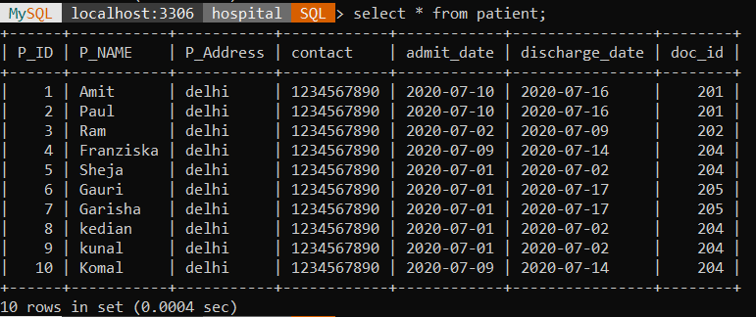

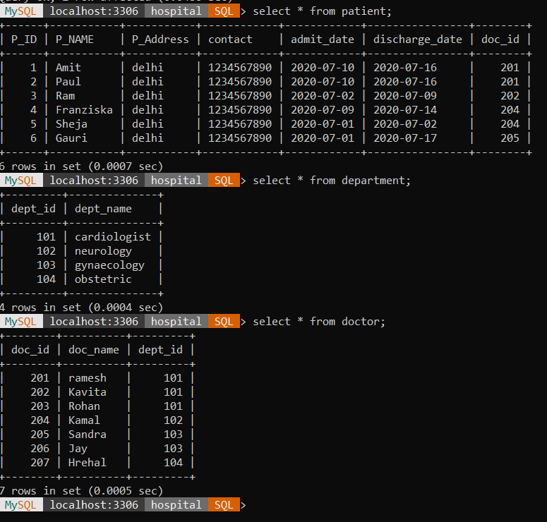

2. Design a query to provide a list of doctors, which department they belong to and patients treated by them (if any).

*Query: select t.doc_id,t.doc_name,t.dept_name,P_Name from (select doc_id,doc_name,dept_name from doctor, department where doctor.dept_id=department.dept_id) as t left join patient on t.doc_id=patient.doc_id;*

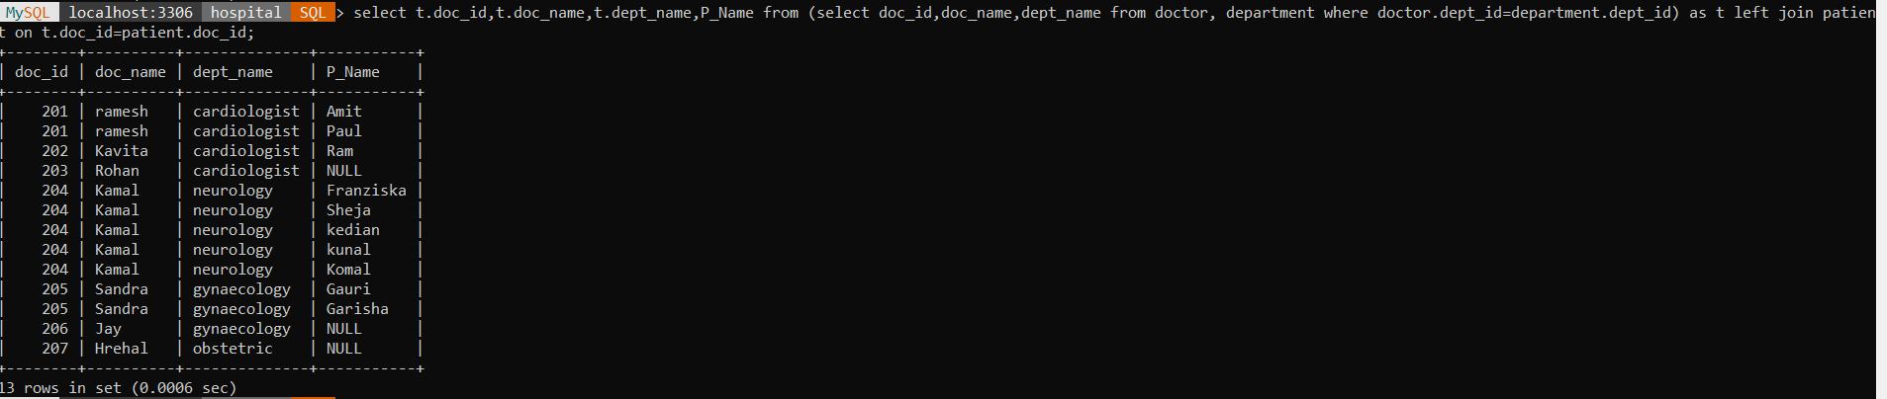

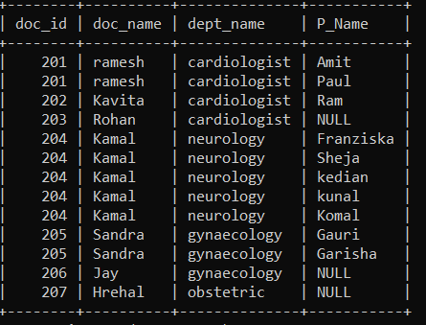

3. Query to provide the count of patients discharged per day in the last week.

*Query: select discharge_date, COUNT(P_Name) as avg_patient_discharged from patient where DATE(discharge_date) BETWEEN '2020-07-11' AND '2020-07-18' GROUP BY discharge_date;*



